Paper Format for the International Journal of Plasma Environmental Science and Technology

A. B. Surname¹, C. D. Surname²
¹Department of Electrical Engineering, University of Orthanc, Isengard
²Department of Power Engineering, University of Hobbiton, Shire

Abstract—This is the format of the paper to be printed in the ISEHD proceedings and International Journal of Plasma Environmental Science and Technology. Page limit is up to 6 pages.
A4 page size of 210 mm × 297 mm (8.27" × 11.69")
Page margine: top and bottom 25 mm, right and left 20 mm
Times New Roman,
Title 14 pt Bold, Author names 12 pt, Affiliation 10pt, Abstract and key words 10 pt bold, main body 10 pt.
Left bottom; name of corresponding author, and e-mail address

Keywords—Fonts, formatting, margins

I. INTRODUCTION

Do not number the manuscript pages.

II. METHODOLOGY

A. Figures and Tables

Figure captions should be below the figures; table names and table captions should be above the tables. Use the abbreviation “Fig.” even at the beginning of a sentence.

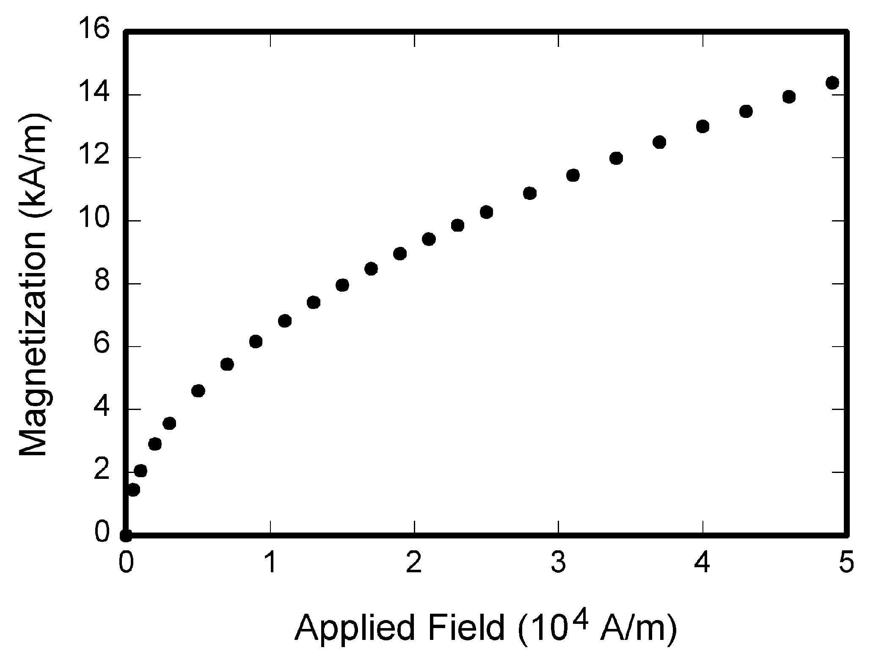

Fig. 1. Magnetization as a function of applied field.
Note how the caption is centered in the column.

Figure axis labels are often a source of confusion. Try to use words rather than symbols. As an example, write the quantity “Magnetization,” or “Magnetization M,” not just “M.” Put units in parentheses. Do not label axes only with units. As in Fig. 1, for example, write “Magnetization (A/m)” or “Magnetization (Am⁻¹),” not just “A/m.” Do not label axes with a ratio of quantities and units. For example, write “Temperature (K),” not “Temperature/K.”
Multipliers can be especially confusing. Write “Magnetization (kA/m)” or “Magnetization (10³ A/m).” Do not write “Magnetization (A/m) × 1000” because the reader would not know whether the top axis label in Fig. 1 meant 16000 A/m or 0.016 A/m. Figure labels should be legible, approximately 10-point type.

TABLE I
TYPE SIZES FOR CAMERA-READY PAPERS

Type Size (pts) | Appearance
Type Size (pts) | Regular | Bold |  | Italic
7 | Table captions ª
8 | Section titles, tables, table names ª, first letters in table captions ª, table superscripts, figure captions, text subscripts and superscripts,  references, footnotes
9 |  | Abstract
10 | Authors’ affliations, main text, equations, first letter in section titles ª, first letter in table names ª |  |  | Subheading
12 | Authors’ names
14 |  | Papertitle
 | ª Capital letters

B. References

The editorial board of IJPEST strongly asks to the authors to refer at least 15 papers without self-citation. This is to improve the IF in near future.
Number citations consecutively in square brackets [1]. The sentence punctuation follows the bracket [2]. Refer simply to the reference number, as in [3]. Do not use “Ref. [3]” or “reference [3]” except at the beginning of a sentence:
“Reference [3] shows ... .”
Please note that the references at the end of this document are in the preferred referencing style. Give all authors’ names; do not use “et al.” unless there are six authors or more. Use a space after authors' initials. Papers that have not been published, even if they have been submitted for publication, should be cited as “unpublished” [4]. Papers that have been accepted for publication should be cited as “in press” [5].
Capitalize only the first word in a paper title, except for proper nouns and element symbols. For papers published in translation journals, please give the English citation first, followed by the original foreign-language citation [6].

C. Equations

Number equations consecutively with equation numbers in parentheses flush with the right margin, as in (1). To make your equations more compact, you may use the solidus ( / ), the exp function, or appropriate exponents. Use a long dash rather than a hyphen for a minus sign. Use parentheses to avoid ambiguities in denominators. Punctuate equations with commas or periods when they are part of a sentence, as in

A + B = C. (1)

ACKNOWLEDGMENT

The preferred spelling of the word “acknowledgment” in American English is without an “e” after the “g.” Use the singular heading even if you have many acknowledgments. Avoid expressions such as “One of us (J.Q.A.) would like to thank ... .” Instead, write “J. Q. Author thanks ... .” Sponsor and financial support acknowledgments are placed in the unnumbered footnote on the first page.

REFERENCES
- D. J. Beebe, “Signal conversion (Book style with paper title and editor),” in Biomedical Digital Signal Processing, W. J. Tompkins, Ed. Englewood Cliffs, NJ: Prentice-Hall, 1993, ch. 3, pp. 61–74M. Akay
- M. Akay, Time Frequency and Wavelets in Biomedical Signal Processing (Book style). Piscataway, NJ: IEEE Press, 1998, pp. 123–135
- G. B. Gentili, V. Tesi, M. Linari, and M. Marsili, “A versatile microwave plethysmograph for the monitoring of physiological parameters (Periodical style),” IEEE Trans. Biomed. Eng., vol. 49, no. 10, pp. 1204–1210, Oct. 2002.
- V. Medina, R. Valdes, J. Azpiroz, and E. Sacristan, “Title of paper if known,” unpublished.
- E. H. Miller, “A note on reflector arrays (Periodical style Accepted for publication),” IEEE Trans. Antennas Propagat., in press.
- T. Menendez, S. Achenbach, W. Moshage, M. Flug, E. Beinder, A. Kollert, A. Bittel, and K. Bachmann, “Prenatal recording of fetal heart action with magnetocardiography” (in German), Zeitschrift für Kardiologie, vol. 87, no. 2, pp. 111–8, 1998.
- J. E. Monzon, “The cultural approach to telemedicine in Latin American homes (Published Conference Proceedings style),” in Proc. 3rd Conf. Information Technology Applications in Biomedicine, ITAB´00, Arlington, VA, pp. 50–53.
- F. A. Saunders, “Electrotactile sensory aids for the handicapped (Presented Conference Paper style),” presented at the 4th Annu. Meeting Biomedical Engineering Society, Los Angeles, CA, 1973.
- J. R. Boheki, “Adaptive AR model spectral parameters for monitoring neonatal EEG (Thesis or Dissertation style),” Ph.D. dissertation, Biomed. Eng. Program, Univ. Fed. Rio de Janeiro, Rio de Janeiro, Brazil, 2000.
- J. P. Wilkinson, “Nonlinear resonant circuit devices (Patent style),” U.S. Patent 3 624 12, July 16, 1990.
- O. Yanez, private communication, May 2002.
- IEEE Criteria for Class IE Electric Systems (Standards style), IEEE Standard 308, 1969.
- R. E. Haskell and C. T. Case, “Transient signal propagation in lossless isotropic plasmas (Report style),” USAF Cambridge Res. Lab., Cambridge, MA Rep. ARCRL-66-234 (II), 1994, vol. 2.
- (Handbook style) Signal Processing Toolbox (4.0) User´s Guide, The Math Works, Natick, MA, 1998, pp. 6-267–6-270.
- (Basic Book/Monograph Online Sources) J. K. Author. (year, month, day). Title (edition) [Type of medium]. Volume(issue). Available: http://www.(URL)
- J. Jones. (1991, May 10). Networks (2nd ed.) [Online]. Available: http://www.atm.com
- (Journal Online Sources style) P. M. Scriber. (year, month). Title. Journal [Type of medium]. Volume(issue), paging if given. Available: http://www.(URL)

